1. Use Case Diagram
The diagram illustrates the core functional requirements of a Smart Parking System by mapping out how two distinct users interact with it. The Parking Staff handles the daily on-ground operations, specifically entering incoming vehicle details and releasing parking slots when vehicles exit. On the administrative side, the Administrator manages high-level oversight by viewing system logs and generating operational reports. Both roles share the ability to view real-time parking status, ensuring data transparency across the system.

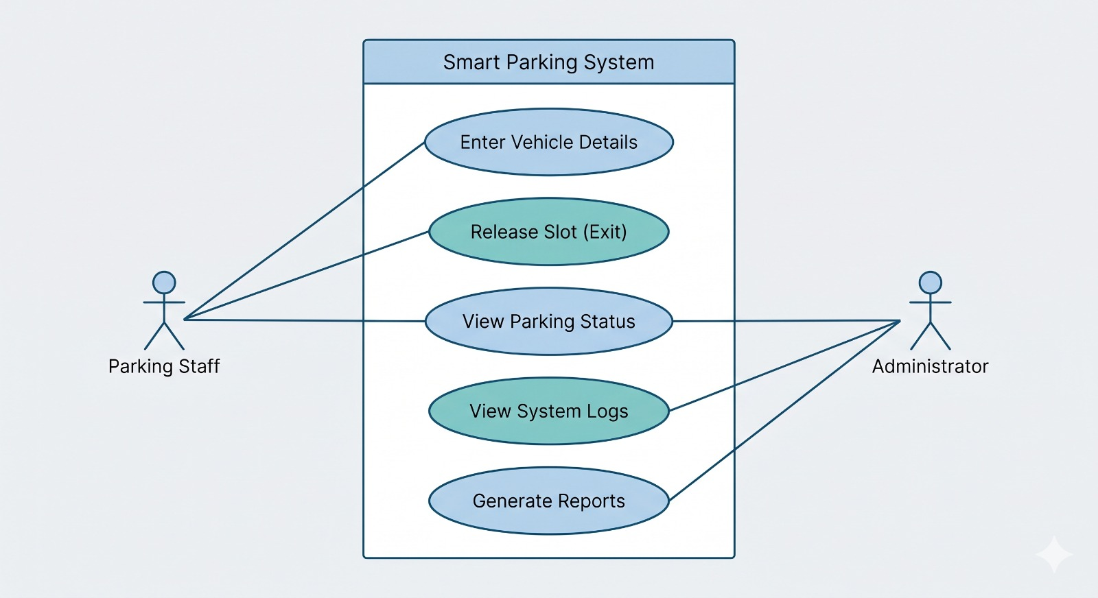

2. ER Diagram (Chen Notation)
This diagram establishes the core conceptual database architecture for the system, structured cleanly around a central transaction hub known as the PARKING_LOG. This log acts as a master ledger tracking entry times, exit times, and unique log IDs. Surrounding tables capture distinct domain modules: USERS tracks operator credentials and permission roles, SLOTS tracks real-time bay allocation status, and VEHICLES links distinct license plates directly to active transaction entries.
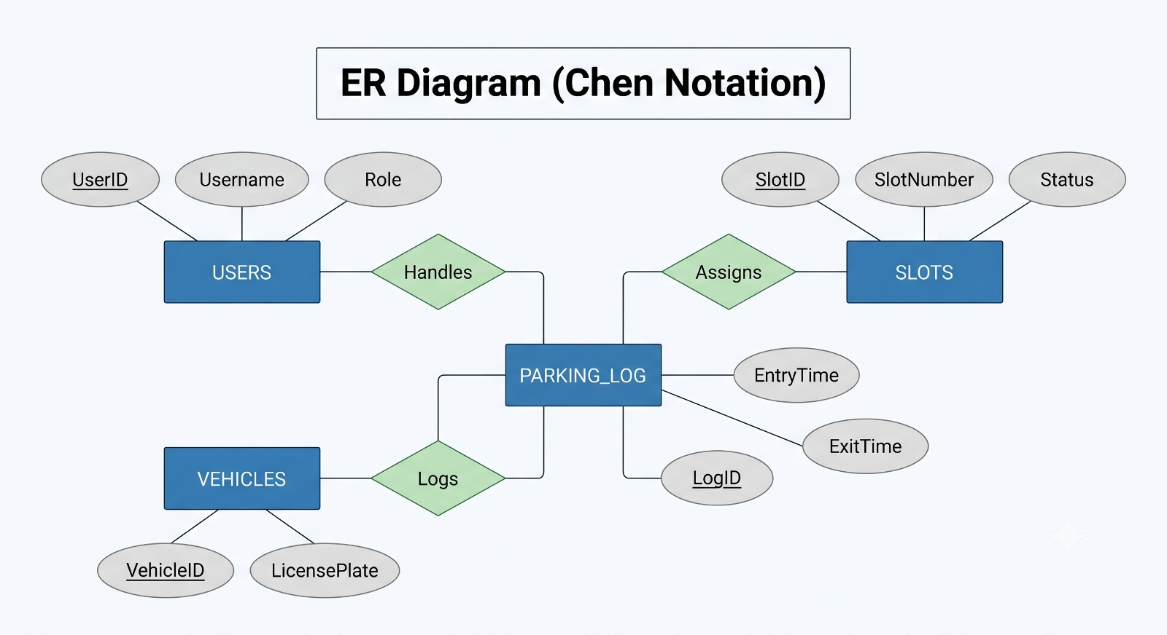

3. EER Diagram (Crow's Foot Notation)
Transitioning from concept to logical physical database schema, this diagram outlines explicit data structures, logical data types (such as integers, variable characters, and date-times), and relational constraints. Utilizing strict One-to-Many (1:N) cardinalities via Crow's Foot syntax, it enforces strict relational mapping where unique spaces, individual cars, and operating profiles dynamically populate foreign keys inside individual transaction logs.
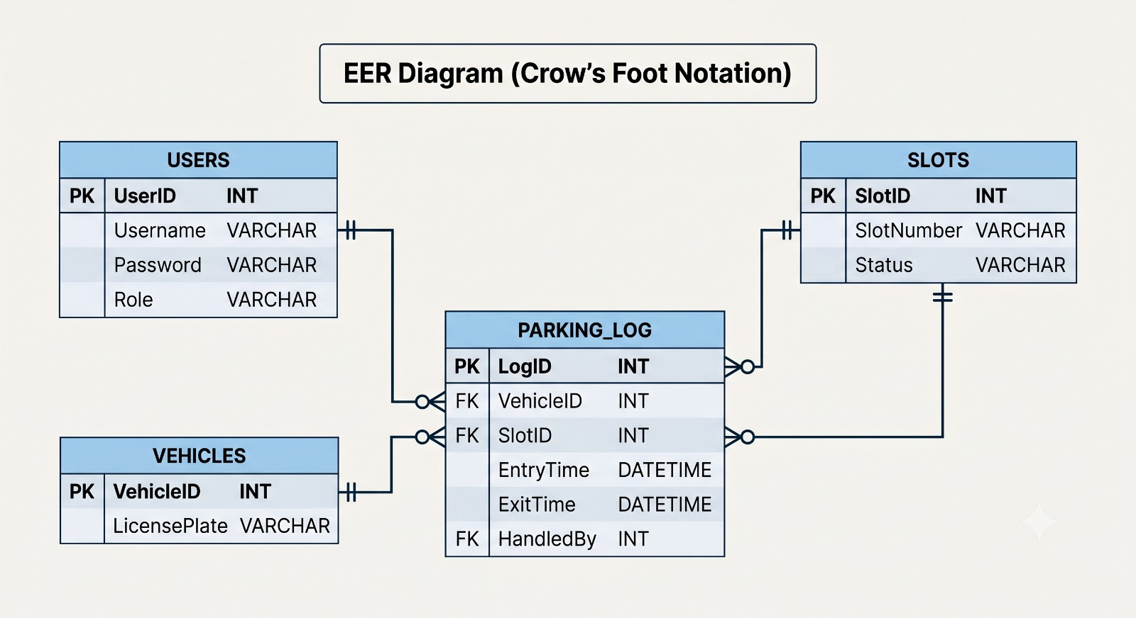

4. DFD Level 0 (Context Diagram)
The context diagram defines the absolute boundaries of the system process environment. Represented as a centralized system node, it maps essential data exchanges with external roles. On-ground staff input vital vehicle license values and exit triggers to receive instantaneous slot status responses, while management administrators issue automated requests to pull back comprehensively compiled performance metrics and analytics logs.
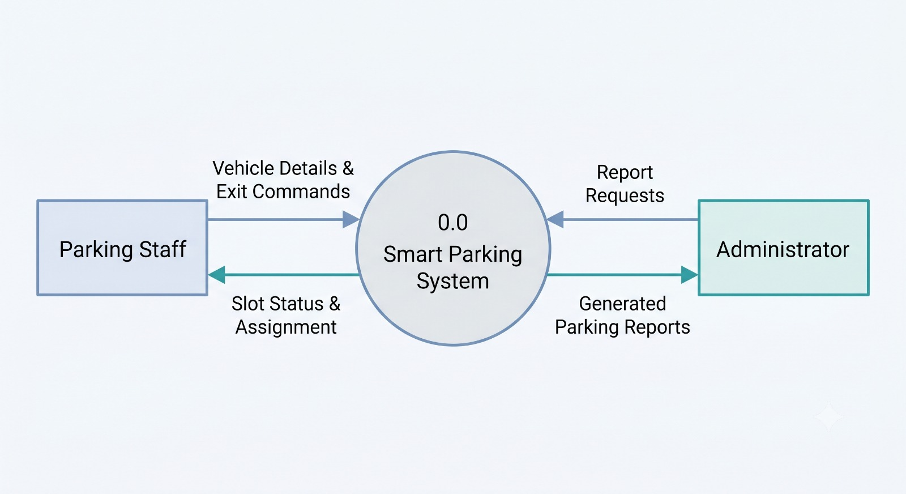

5. DFD Level 1 (System Architecture)
Deconstructing the central system boundaries into distinct internal sub-processes, this level outlines the programmatic routing of active data pools. It segments the system workflow into core operational logic engines: vehicle entry processing, vehicle exit sequencing, dynamic display calculation engines, and report compilation engines. These programs communicate concurrently with dedicated storage slots and historical log files.
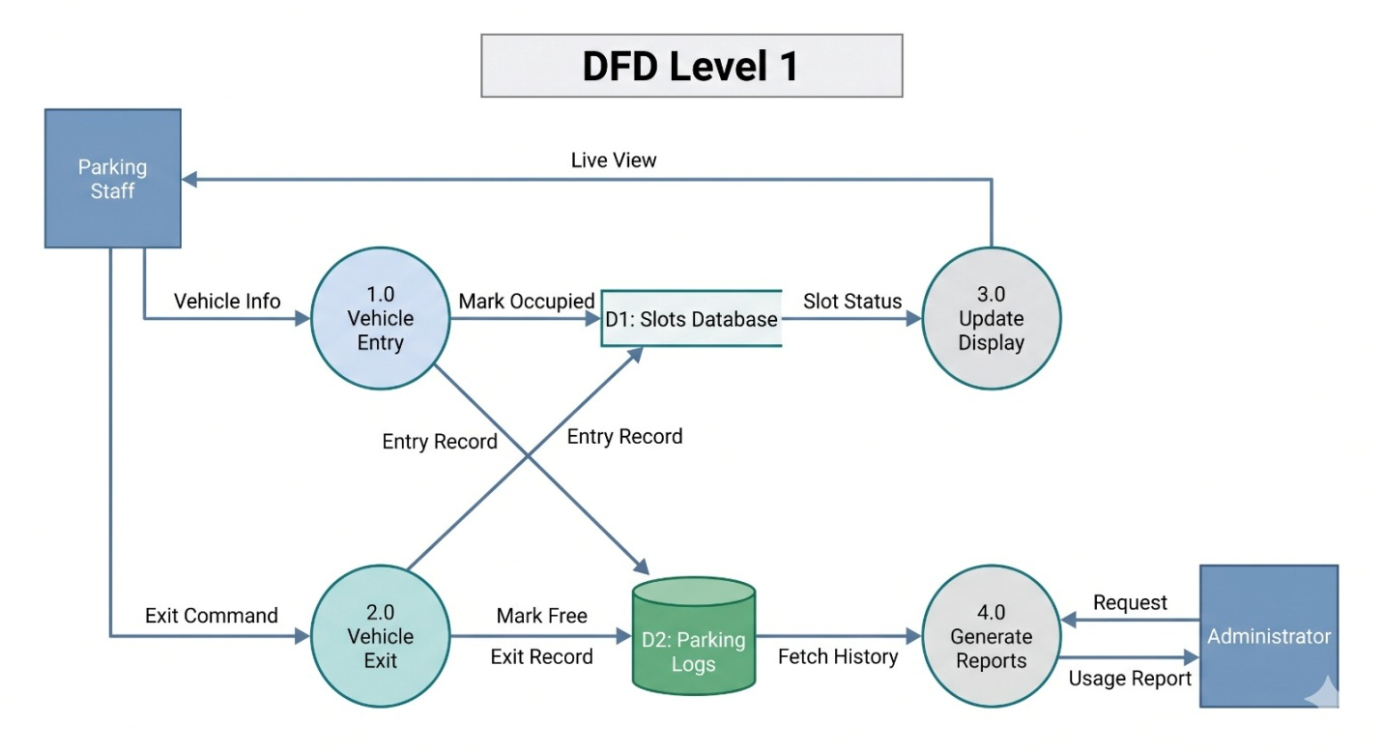

6. DFD Level 2 (Vehicle Entry Process)
This diagram zooms into the technical sequence executed when an incoming car arrives. It details the precise tracking cycle: from parsing an incoming vehicle's license plate data via staff interaction, referencing available slots within the inventory ledger, allocating an open target coordinate ID, and finally updating the status field to occupied while saving historical registration records.
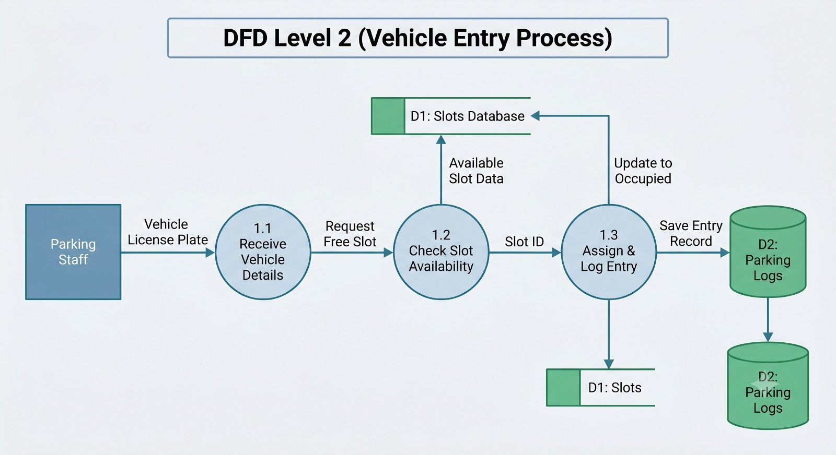

7. DFD Level 2 (Vehicle Exit Process)
This diagram details the exact technical routines triggered whenever a parked car departs the lot. Staff initialize exit updates by transmitting corresponding slot indices or car numbers. The system instantly clocks out the vehicle by writing exit times into historical logs, executing real-time clear indicators, and changing target allocation indices back to an open status to allow subsequent vehicle assignments.
